# Lab 18

Instructor: Sidra Khatoon E-mail: skhatoon[@uit.edu](mailto:ad@uit.edu)

# Objective

# The objective of lab is explore the HTTP in flutter

**Student Information**

|  |  |
| --- | --- |
| **Student Name** |  |
| **Student ID** |  |
| **Date** |  |

**Assessment**

|  |  |
| --- | --- |
| **Marks Obtained** |  |
| **Remarks** |  |
| **Signature** |  |

# Objective

# The objective of lab is explore the HTTP in flutter

# Instructions

You have to perform the following tasks yourselves. Raise your hand if you face any difficulty in understanding and solving these tasks. **Plagiarism** is an abhorrent practice and you should not engage in it.

# How to Submit?

Submit lab work using Teams.

# Flutter - Make an HTTP GET Request

# In app development, the ability to fetch data from external sources, such as REST APIs, is a fundamental requirement. In Flutter, Whether you need to fetch data from a RESTful API, access a database, or retrieve content from a web server, Flutter provides you with the tools and packages(HTTP) to do this kind of API calls easily. Here we will explore how to interact with external data sources, retrieve JSON data, and integrate it into your Flutter application.

# About the API

# This is a joke API that gives a Random joke in each API call.

# API Request method:

# GET - https://api.chucknorris.io/jokes/random

# JSON Data Format (Sample):

# {

# "categories": [],

# "created_at": "2020-01-05 13:42:28.984661",

# "icon_url": "https://assets.chucknorris.host/img/avatar/chuck-norris.png",

# "id": "plj3-pqiRWuomVQKAy_AwQ",

# "updated_at": "2020-01-05 13:42:28.984661",

# "url": "https://api.chucknorris.io/jokes/plj3-pqiRWuomVQKAy_AwQ",

# "value": "Chuck Norris can have his cake, eat it, then roundhouse kick you in the face with the extra power it gave him."

# }

# Step By Step Implementations

# Step 1: Create a New Project in VS code

# Create a new project in VS code name as per your choice.

# Step 2: Add the dependency to our project

# In the pubspec.yaml file we have to add the below dependency for the http package which provide varrious API call methods.

# 

# Step 3: Import the Package

First of all import material.dart file.



# Step 4: Create the DataModel for the JSON

# Here we are going to create a DataModel class to retrieve our jokes from the API.

# 

# Step 5: Execute the main Method

# Here the execution of our app starts.

# 

# Step 6: Create MyApp Class

In this class we are going to implement the MaterialApp , here we are also set the Theme of our App.

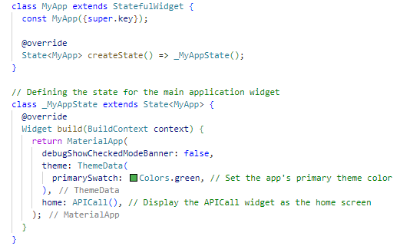

# Step 7: Create APICall Class

In this class we are going to make HTTP GET request to the API endpoint and fetch the data from it.

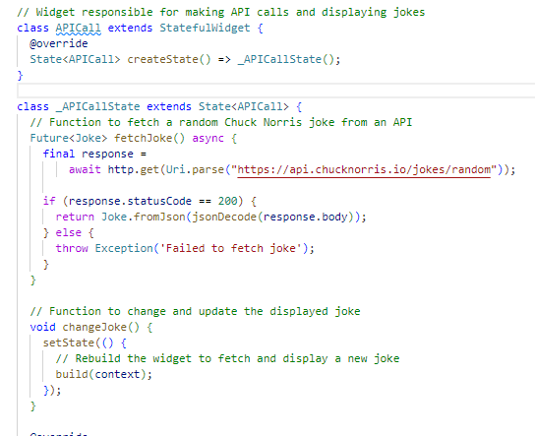

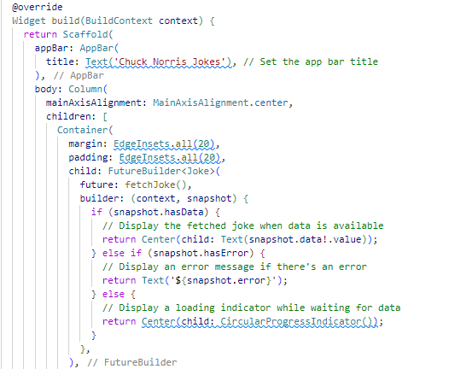

# 

# Flutter - Make an HTTP POST Request:

# In app development, the ability to fetch data from external sources, such as REST APIs, is a fundamental requirement. In Flutter, whether you need to send some data to the RESTful API, access a database, or then Send content from the Flutter App, Flutter provides you with the tools and packages(HTTP) to do this kind of API calls easily. Here we will explore how to interact with external data sources, Send JSON data(Key-Value pairs), and integrate it into your Flutter application.

# About the API

# This is a joke API that gives a Random joke in each API call.

# API Request method:

# POST - https://jsonplaceholder.typicode.com/posts

# Step By Step Implementations

# Step 1: Create a New Project in VS code

# Create a new project in VS code name as per your choice.

# Step 2: Add the dependency to our project

# In the pubspec.yaml file we have to add the below dependency for the http package which provide varrious API call methods.

# 

# Step 3: Import the Package

First of all import material.dart file.



# Step 4: Execute the main Method

# Here the execution of our app starts.

# 

# Step 5: Create MyApp Class

In this class we are going to implement the MaterialApp , here we are also set the Theme of our App.

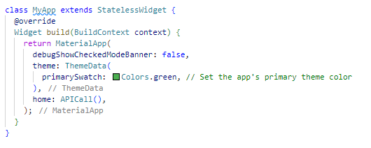

# Step 6: Create APICall Class

# In this class we are going to make HTTP POST request to the API endpoint and Display the result that would received from the API (Sucess Status Code for this API call is 201).

# 

# 

# 

**Assessments:**

1. **What is a RESTful API?**
2. **How do you send data with an API call?**
3. **What are the common HTTP methods used in API calls?**
4. **How do you parse JSON data from an API response?**